*Use for the Foundation. Do not fill in this column.

|  |  |
| --- | --- |
| Ref. No. | **24** － |

**Outline of Research (1/3)**

**【Title of Research】**

|  |  |
| --- | --- |
| Title | Clean energy integration into Agriculture to mitigate poverty of backward caste farmers in India |
| Subtitle (if any) | Creating a Solar-Agriculture-Poverty-Equality (SAPE) Nexus |

**【Purpose of Research】**

State below the purpose of research including how it is related to the major mission of the Foundation: “Promoting international understanding” and “Co-existence of nature and mankind.”

*＊Use font size of 10.5-point or bigger. Do not add pages.*

**Background:**

While net-zero targets are the center of energy policy in recent years, transition from fossil fuels (FF) to renewable energy (RE) is a very gradual process, specifically for developing nations. India is a very fast-growing emerging economy, where a substantial portion of the primary sectors and power generation is dependent on FF. This will greatly affect the achievement of net-zero targets globally, since India is a major exporter of agricultural products (like spices, tea, cashew, etc.) to multiple nations, including Japan. Due to the informal nature of agriculture in India, it accounts for more than 50% of the entire workforce in India, while contributing to under 20% of the total GDP. This is coupled by the fact that farm landholding size is severely small, compared to the increase in rural population. This has ultimately caused the income of farmers to be very limited, which has resulted in lack of mechanization and electrification in farming processes due to the poverty of farmers, forcing irrigation to be erratic and dependent on rainfall, which further causes agricultural productivity to be very poor. In economic terms, we call this a death spiral.

The second issue is existing government policies that give a subsidy on FF usage (10% of market price) to farmers for farming activities, which prevents RE adoption and penetration into the agricultural sector. This subsidy only aggravates the death spiral effect, which negatively affects tax revenue from oil, rendering domestic oil market unstable

The third issue is the treatment of backward classes in rural and agricultural societies. India still suffers from social ‘caste’ classification, which is determined by birth (not economic status). Access to education is limited for backward castes, and even more so for women belonging to backward castes. Women are often paid 50% of the wage of a male farmer for the same work done. It is in these backward castes that landholding size of farms is limited, and having no other means of income, they belong to the below-poverty-line (BPL) population of India. Thus, from agricultural productivity to RE integration, poverty, class inequality and gender inequality are key interconnected social issues.

**Purpose of Research**:

The social and gender inequalities are pronounced in the Indian states of Bihar and Tamil Nadu, which are selected as case-studies for this research grant. The idea is to evaluate the potential of introducing RE like solar energy into a backward-caste community of farmers, which will not only serve the purpose of maintaining stable irrigation water-supply, but also open the possibility of further income for the farmers by selling the excess electricity to the grid. The aim of this research is to evaluate the poverty-mitigation potential of solar-powered irrigation systems in different regions of India, with varied socioeconomic factors. The economic analysis will also encompass the acceptability of solar among backward-caste farmer populations, and whether it can be replicated throughout India and globally.

*Use for the Foundation. Do not fill in this column.

|  |  |
| --- | --- |
| Ref. No. | **24** － |

**Outline of Research (2/3)**

**【Characteristics of Research】**

State below the characteristics of the research including the potential, expected results, significance to the preceding studies, etc.

*＊Use font size of 10.5-point or bigger. Do not add pages.*

**Potential of the Research:**

The salient features of the Solar-Agriculture-Poverty-Equality (SAPE) nexus lies in the integration of socioeconomic issues with energy transition goals, where it aims to solve four issues simultaneously:

1. Climate Action: With the emission intensity (amount of CO2 emission per unit GDP) of the agricultural sector being the highest in India, solar-powered irrigation could reduce the life-cycle emissions of agriculture considerably.

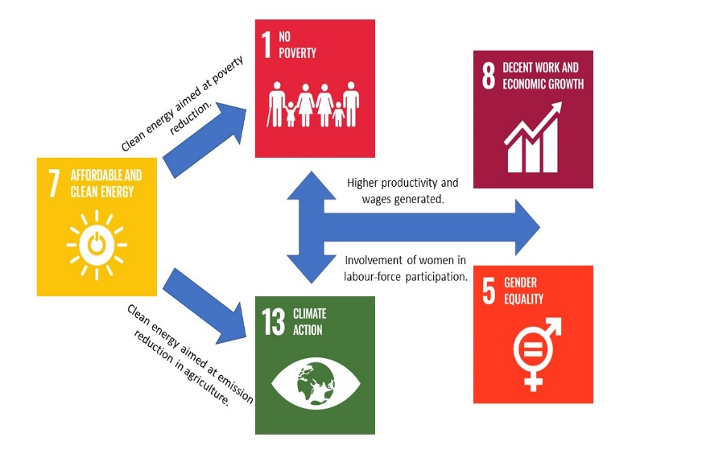2. Economic Action: Firstly, solar-powered irrigation is not dependent on the volatile price of oil, meaning farmers can ensure stable water-supply for crops, increasing productivity. Secondly, distribution companies can benefit from the removal of agricultural oil subsidy, increasing tax revenue and stabilizing the domestic oil market.

3. Poverty Action: The breakeven point of solar installations into the farms are crucial, as it would determine the income generation from excess electricity sold to the grid, which can help farmers come out of BPL incomes.

4. Equality Policy Action: Participation of women and backward castes in maintenance of solar plants can not increase the per capita income for the lower castes, but also create a policy for economic equality across all RE adoption.

Figure: The potential of SDG feedbacks and achievement in this research through the SAPE nexus

**Expected Results:**

1. Participation of backward-caste and gender-equal representation in comprehensive data collection.

2. An empirical marker of how much waste-land in Indian Agriculture can be converted to solar-fields, in backward and minority communities.

3. An empirical coefficient of the acceptability of RE and solar among backward classes.

4. A detailed survey that connects energy-use, water-supply and agro-productivity in minority communities.

5. Connecting NGO actions, government economic policy and climate action for integrating solar into poverty-ridden zones of India, enabling development of decentralized energy transition policy.

**Significance to Preceding Studies:**

1. Several studies on caste-discrimination and access to clean energy [1,2], will be progressed by incorporating a specific sectoral application (agriculture), since farming is the chief occupation of poverty-ridden backward castes.

2. Gender inequality and agricultural income past analysis [3], will be furthered by incorporating caste-based gender discrimination, and RE as a driver to eliminate such discriminations.

3. A plethora of literature demanding further analyses into the socioeconomic issues of energy transition [4], will be addressed in this research, with a comprehensive survey and data being made publicly available.

References: [1] <https://doi.org/10.1016/j.eneco.2022.106080> [2] <https://doi.org/10.1016/j.erss.2020.101530> [3] [https://doi.org/10.1016/j.worlddev.2016.11.004 [4](https://doi.org/10.1016/j.worlddev.2016.11.004%20%5b4)] <https://doi.org/10.1016/j.eneco.2021.105392>

*Use for the Foundation. Do not fill in this column.

|  |  |
| --- | --- |
| Ref. No. | **24** － |

**Outline of Research (3/3)**

**【Research plan / Methodology】**

*＊Use font size of 10.5-point or bigger. Do not add pages.*

The research plan is divided into three stages as shown in the picture below:

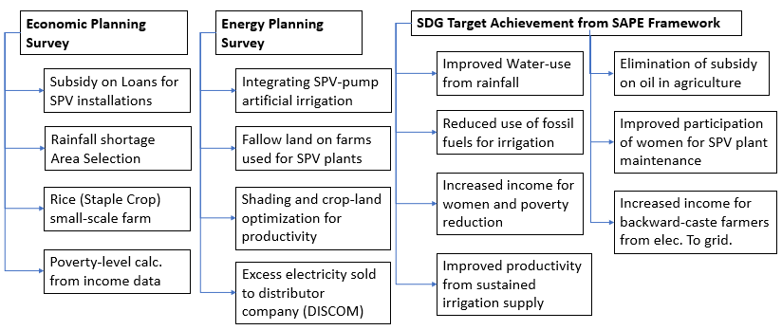

**Stage 1 (Survey, Data and Community)**

Tools for stage 1: Community group discussions (focus group), Interview and questionnaire, Government data and meteorological data.

1. Data collection from focus group communities of more than 100 farmers at the two locations (of majority backward classes) in local language: productivity estimate, oil expenditure, monthly income, household size, caste classification.

2. Local rainfall and electricity data collection (hourly) for last five years, from meteorological centers.

3. Organizing two different pilot workshop discussions with rural government at the two locations and the farmers to explain community solar ideas and expected technicalities. This will give an estimate of the willingness to transition from oil-powered irrigation and rainfed irrigation to solar-powered irrigation.

**Stage 2 (Energy Scenario Simulations)**

Tools for stage 2: GIS data collection and 2D-3D simulations, Statistical models (econometrics)

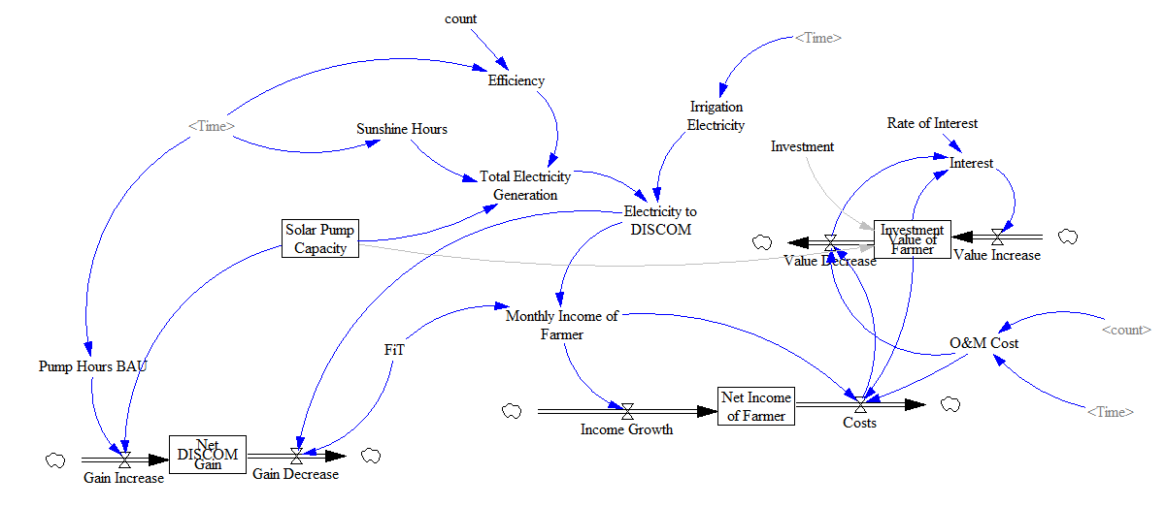1. Land surveys and maps of poverty focus group communities to build GIS layers and check for wasteland (fallow land) within farmer-owned land. This is where solar plants will be simulated to be installed (not taking crop land).

2. General equilibrium and vector models (statistical) to see the dependency of land ownership, wasteland, crop income, energy-use, access to electricity, willingness to adopt solar- variables to derive causality among the variables.

3. Simulation of system dynamic models to have probabilistic estimates of all the above-shown SDG target achievement indicators for both the farmers and the government benefit. *A simple figure is shown as to how this model might look like in the figure on the right.*

**Stage 3 (Validations and Policy Recommendations)**

1. Present the simulation results at an international academic conference to get feedback on the proposed model and relevant academic insights on the theoretical socioeconomic approaches.

2. With the academic feedback, government and energy planning communities will be contacted to check the feasibility of the analysis based on a further interview.

3. These final results will be summarized in an academic journal publication with expert insights on the model, for policy recommendations to adopt the SAPE nexus for backward-caste poverty-ridden farmer communities.

*Use for the Foundation. Do not fill in this column.

|  |  |
| --- | --- |
| Ref. No. | **24** － |

|  |
| --- |
| **Summary of the master / doctor thesis**  **【Title of the thesis】** |
| MASTER THESIS (09/2021): Assessing the Socio-Economic Impacts on Energy Issues and Energy Development in India |
| **【Summary of the thesis】**  *＊Use font size of 10.5-point or bigger. Do not add pages.* |
| The thesis focuses on the third largest emitter of CO2, India, and dictates critical socio-economic policies for achieving energy transition at a macro-level, through three related studies.  **The first study** focuses on decoupling emissions from economic growth in developing societies, like India, via a ***literature review*** of 93 investigations. The main factors that inhibit decoupling were found to be economic growth, fossil fuel-use and urbanization of population, while the promoting factors are energy intensity reduction and emission intensity reduction. Upon comparison, it was found that emission intensity reduction is more effective than energy intensity reduction, as the former does not depend on the fluctuations of economic growth. Renewable energy development can foster emission intensity reduction.  **The second study** focuses on understanding the geographical socioeconomics of solar energy plants in India by analysis of location-dependent costs. ***A spatial parameterization model*** is used for examining the factors causing spatial variation of the installation costs of land, labor, transmission and supply chains for suburban SPV plants, within a geographic boundary. The model is applied to Kolkata city, India, and the spatial variation of the costs are checked in a 2500 km2 suburban boundary. The spatial variation of the location-dependent costs is mainly caused by the distance from an economic focal point of the city. The variations significantly optimize at minima points in the 2500km2 boundary. The spatial minima are mainly caused by variance of land and transmission costs. This minima location lies on the extrapolation of a line that connects the city focal point with the substation. The capacity of the SPV plants at the optima increases with increasing transmission voltage (11kV to 66kV), ranging from 4MW to 257MW in the case-study, while the minima shift away from the city focal point (ranging 29km to 48km) with increasing capacity.  **The third study** is an examination of ***time-series control system analysis for energy-economy-emission nexus*** in India. 11 socio-economic models are tested based on their reproducibility and forecasting capability prior and post-2008 financial crisis impact in India. A multivariate model combining trade, Gross Domestic Product (GDP), capital, heat and electricity-use, Consumer Price Index (CPI), emissions and energy imports proved to best reproduce the nexus from 1996 to 2008 and predict the condition after the 2008 crisis with an error less than 1% and approximate entropy of 0.43. Upon applying the model to predict the impact of COVID-19 induced economic recession in India, it was found that CO2 emissions and heat energy-use are coupled to GDP. The chance to reduce emissions come from renewable energy development in electricity sector, with electricity being coupled to consumer behavior and financial development (CPI) |

*Use for the Foundation. Do not fill in this column.

|  |  |
| --- | --- |
| Ref. No. | **24** － |

**Budget**

No need to fill out this column.

Fill in the same amount as “amount of grant

requested” on your application form.

|  |  |  |  |  |  |  |  |  |  |  |  |  |
| --- | --- | --- | --- | --- | --- | --- | --- | --- | --- | --- | --- | --- |
| **【Details of Expenditure】**　 ＊Refer to the “Items of Expenditure” on the application guidelines. | | | | | | | | | | | | |
| Items | | | | | | | Amount (Yen) | | | Breakdown / Details | | |
| **1)** | | Personnel | | | | |  | | |  | | |
|  | | Reward / payment to cooperators | | | | | 60,000 | | | Gift and payment to farmer community focus group participants | | |
|  | | Reward / payment to assistants | | | | | 60,000 | | | Payment and invoicing to data department for data on rainfall, electricity-use and maps | | |
| 2) | | Travel | | | | |  | | |  | | |
|  | | Domestic travel | | | | | 30,000 | | | International energy conference in Japan | | |
|  | | Overseas travel | | | | | 150,000 | | | Travel to India for surveys, data and interviews | | |
| **3)** | | Survey / equipment | | | | |  | | |  | | |
|  | | Contract survey | | | | | 50,000 | | | Pilot Workshop for Solar-powered irrigation arrangements for farmers | | |
|  | | Computer software, other | | | | | 20,000 | | | GIS and map simulation packages | | |
| 4) | | Documents & copying | | | | |  | | |  | | |
|  | | Purchase of books | | | | |  | | |  | | |
|  | | Materials | | | | |  | | |  | | |
|  | | Printing / copying | | | | | 30,000 | | | Printing (bound proposals, leaflets, banners) for local farmers, government personnel, data agencies | | |
| 5) | | Conference | | | | |  | | |  | | |
|  | | Rent for a venue | | | | | 40,000 | | | Renting venues for workshops and community discussions in rural areas | | |
|  | | Miscellaneous | | | | | 50,000 | | | Registration fees for International energy conference in Japan | | |
| 6) | | Communication / Transportation | | | | | 10,000 | | | Transportation by train to the rural areas for data collection and conducting surverys | | |
| 7) | | Consumables | | | | |  | | |  | | |
| 8) | | Miscellaneous | | | | |  | | |  | | |
| **Total** | | | | | | | 50,0000 | | |  | | |
| **【Breakdown of total budget】** | | | | | | | | | | | | |
|  | | | | | | | | | Main item of expenditure | | Amount (Yen) | | |
| Own fund | | | | | | | | | Transportation in India and Japan | | 10,0000 | | |
| K. Matsushita Foundation  (amount of grant requested) | | | | | | | | | Complete Research preparation and conducting | | 50,0000 | | |
| Other grant, etc. | | | | | | | | |  | |  | | |
| Grand total | | | | | | | | |  | | 60,0000 | | |
| *Use for the Foundation. Do not fill in this column.   |  |  | | --- | --- | | Ref. No. | **24** － |   **Academic Background and Recommender** | | | | | | | | | | |
| Personal History | | | | | Please write your academic background and professional career after completing undergraduate courses. | | | | | |
| *yyyy . mm* | | | | *\* Please write in order oldest on top and newest at the bottom* | | | | | | |
| 2016 | | ・ | 7 | Technical Associate, Patent Prosecution Dept., Clairvolex Knowledge Processes, India. | | | | | | |
| 2017 | | ・ | 12 | Senior Research Associate, Patent Prosecution Dept., Evalueserve SEZ Pvt. Ltd., India | | | | | | |
| 2019 | | ・ | 9 | Master’s Student, Graduate School of Energy Science, Kyoto University, Japan | | | | | | |
| 2021 | | ・ | 10 | Instructor (English), GABA Corporation, Japan | | | | | | |
| 2021 | | ・ | 10 | PhD Student, Graduate School of Energy Science, Kyoto University, Japan | | | | | | |
|  | | ・ |  |  | | | | | | |
|  | | ・ |  |  | | | | | | |
|  | | ・ |  |  | | | | | | |
|  | | ・ |  |  | | | | | | |
|  | | ・ |  |  | | | | | | |
| **Major achievements related to**  **this research** | | | | | | | (Please list up to 5 major achievements you have accomplished in  the past 5 years including publications, thesis, etc.) | | | |
| 1. **Scholarship**: KMMF Master’s Scholar, 10/2019 to 9/2021 for Masters study at Kyoto University.  2. **Scholarship**: Japan Science and Technology Agency (JST) Spring fellow from 10/2021 to 09/2024 for PhD studies at Kyoto University.  3. **Publication**: S. Basu, T. Ogawa, H. Okumura, K. N. Ishihara; Assessing the geospatial nature of location-dependent costs in installation of solar photovoltaic plants; Energy Reports, Vol. 7, pp. 4882-4894 (2021).: <https://doi.org/10.1016/j.egyr.2021.07.068>.  4. **Publication**: Basu, S., Usher, K., Tamiya, H., Akasegawa, R., Hui, Y., Chen, Q., Cravioto, J., & Ohgaki, H. (2024). Synergies and trade-offs quantification from regional waste policy to sustainable development goals: The case of Kyoto City. Sustainable Development, 1–21. <https://doi.org/10.1002/sd.3001>.  5. **Publication**: Basu, S., Ishihara, K.N. Multivariate time–frequency interactions of renewable and non-renewable energy markets with macroeconomic factors in India. Energy Syst (2023). <https://doi.org/10.1007/s12667-023-00617-9>. | | | | | | | | | | |

**Recommender**（A person who writes your recommendation letter）

|  |  |
| --- | --- |
| Name | Hideyuki Okumura |
| Organization / position | Associate Professor  Graduate School of Energy Science,  Kyoto University |